

**Faculty of Engineering & Technology**

**Electrical & Computer Engineering Department**

**Communications Lab-****ENEE4113**

**Report #2 Experiment 6**

**Pulse Amplitude Modulation (Sampling)**



**Prepared by:** Ansam Hababeh  **ID:** 1201127

**Partners**: Entisar Qandil **ID:**1200073

**Instructor**: Dr. Ashraf Al-Rimawi

**Assistant**: Eng. Hazem Awaysa

**Section:** 1

**Date:** 16/1/2024

# **Abstract**

This experiment aims to translate theoretical knowledge of pulse trains, phase amplitude modulation, time multiplex modulation, demodulation in different values of VSS and frequency for input signal or function generator and different values of duty cycle, sampling, Nyquist rate, and aliasing in time and frequency domain, and pulse amplitude modulation (PAM) in time and frequency domain into practical expertise. To arrive at a conclusion, take the wave form in the time and frequency domain at various component values, compare them, and figure out how much they differ from one another.

Contents

**Abstract** 2

**1.** **Theory** 6

**1.1** **Pulse train function** 6

**1.2** **Sampling** 7

**1.3** **Aliasing** 8

**1.4** **Time Division Multiplexing (TDM)** 8

**2.** **Procedure** 10

**2.1** **Time and Frequency Characteristics of pulse train** 10

**2.2** **Characteristics of Pulse Amplitude Modulation (PAM)** 14

**2.2.1** **Study the effect of the channel filter (CH1):** 15

**2.2.2** **Display the Pulse Amplitude Modulated signal s(t) of PAM1 in the time domain:** 16

**Determining the effect of the duty cycle on the PAM in the time domain:** 18

**Display the Pulse Amplitude Modulated signal s(t) of PAM1 in the Frequency domain:** 20

**Determining the effect of the message frequency on the PAM in the Frequency domain:** 20

**Determining the effect of the duty cycle on the PAM in the Frequency domain:** 22

**2.2.3** **Display the Pulse Amplitude Modulated signal s(t) of PAM2 in the time domain:** 24

**Determining the effect of the duty cycle on the PAM in the time domain:** 24

**Display the Pulse Amplitude Modulated signal s(t) of PAM2 in the Frequency domain:** 25

**Determining the effect of the message frequency on the PAM in the Frequency domain:** 26

**Determining the effect of the duty cycle on the PAM in the Frequency domain:** 28

**2.3** **Characteristics of Pulse Amplitude Demodulation** 31

**Display the message signal and the demodulated signal using PAM1:** 31

**Determining the effect of the duty cycle on the PAM in the time domain:** 33

**2.4** **Aliasing in the Time and the Frequency Domains** 37

**Display the message signal and the demodulated signal using PAM1 in the time domain:** 37

**Display the message and the demodulated signals using PAM1 in the frequency domain:** 38

**2.5** **PAM Time Multiplex** 41

**Display the time characteristic of the time multiplex signal.** 41

**Connect the CASSY sensor UA1 to the sine message channel CH1.** 42

**When Connect the CASSY sensor UA1 to the demodulator filter CH1, sensor UB1 to the** 43

**demodulator filter CH2.** 43

**Cross Talk (Δt) left/middle** 44

**Conclusion** 48

**References** 49

# Table of figures

Figure 1:Pulse train on time domain. 8

Figure 2:The spectrum of pulse (the train of delta in frequency domain). 9

Figure 3:sampling 10

Figure 4:Aliasing 10

Figure 5:Time Division Multiplexing (TDM) 11

Figure 6:Connected of pulse train generator. 12

Figure 7:Pulse train with duty cycle = 10% in time domain. 12

Figure 8:Spectrum of the pulse train with duty cycle =10%. 13

Figure 9:Zero crossings with different duty cycles. 14

Figure 10:Pulse train with duty cycle = 20% in time domain. 14

Figure 11:Spectrum of the pulse train with duty cycle =20%. 15

Figure 12:Connected of PAM. 16

Figure 13:Spectral of pulse at 5 KHz and 15 KHz. 16

Figure 14:Original message signal with filtered message signal. 17

Figure 15:Spectrum of Original message signal and filtered message signal 18

Figure 16:modulated signal S(t) of PAM1 and input signal in time domain with duty cycle 50%. 19

Figure 17:Spectrum of modulated signal S(t) of PAM1 and input signal. 20

Figure 18:Modulated signal S(t) of PAM1and input signal with minimum value duty cycle =10% in time domain. 21

Figure 19:Spectrum of modulated signal S(t) of PAM1and input signal with minimum value duty cycle =10% 21

Figure 20:Frequency-domain modulated signal PAM1 s(t) with the clock spectrum. 22

Figure 21:PAM1 signal at 1KH in frequency domain. 23

Figure 22:PAM1 signal at 2KH in frequency domain. 24

Figure 23:Spectrum of PAM1 with fm=500Hz and duty cycle = 10%. 25

Figure 24:Spectrum of PAM1 with fm=500Hz and duty cycle = 30%. 25

Figure 25:PAM2 modulated signal s(t) time domain. 26

Figure 26:PAM2 with minimum duty cycle. 27

Figure 27:Spectrum of PAM2 maximum duty cycle. 28

Figure 28:PAM2 spectrum at 1KHz. 29

Figure 29:PAM2 spectrum at 2KHz. 30

Figure 30:Spectrum of PAM2 with duty cycle 10%. 31

Figure 31:Spectrum of PAM2 with duty cycle 30%. 32

Figure 32:demodulated signal with filtered input signal in time domain. 33

Figure 33:demodulated signal with filtered input signal in frequency domain. 34

Figure 34:Demodulation of message signal and input signal with duty cycle =10% in time domain. 35

Figure 35:Demodulation of message signal and input signal with duty cycle =10% in frequency domain. 36

Figure 36:Demodulation of message signal and input signal with duty cycle =30% in time domain. 37

Figure 37:Demodulation of message signal and input signal with duty cycle =30% in frequency domain. 38

Figure 38:Aliasing output signal in time domain. 39

Figure 39:Output of demodulator filter in time domain. 40

Figure 40:spectrum of clock generator with PAM1. 41

Figure 41:Output of demodulator filter with PAM1. 42

Figure 42:Connected of PAM time multiplex. 43

Figure 43:Output PAM modulator PAM1 with triangle message signal. 43

Figure 44:Output PAM modulator PAM1 with sine message signal. 44

Figure 45:Output PAM modulator PAM1 with sine message signal in frequency domain. 45

Figure 46:demodulator filter in ch1 and ch2 in time domain. 45

Figure 47:demodulator filter in ch1 and ch2 in frequency domain. 46

Figure 48:Cross Talk in time domain. 46

Figure 49:Cross Talk in frequency domain. 47

Figure 50:Cross Talk with triangle in time domain. 47

Figure 51:Cross Talk with triangle in frequency domain. 48

Figure 52:Cross Talk with sine in time domain. 48

Figure 53:Cross Talk with sine in frequency domain. 49

# **Theory**

## 

* 1. **Pulse train function**

Converting a continuous signal into a discrete signal yields a pulse train, alternatively known as a pulse sequence or waveform. A pulse train consists of recurring pulses characterized by a specific duration and frequency within the signal. Each pulse train is associated with a duty cycle value, representing the percentage of time during which the pulse remains in the high or "on" mode, divided by the total period of the pulse.[1]

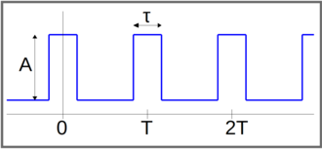

Figure 1:Pulse train on time domain.

The duty cycle depicted in Figure is defined as Duty Cycle = τ / T0, where τ represents the duration when the pulse is in the high (on) state, and T0 corresponds to the time for one complete period. In the context of a pulse train, its Fourier transform manifests as a sequence of delta functions evenly spaced in the frequency domain.

The Fourier transform equation for the pulse train is expressed as:

*X*(*f*)=*T*⋅∑*δ*(*f*−*k*⋅*f*0​)

Here, T denotes the period of the pulse train, f represents frequency, *f*0​ is the fundamental frequency, and the sum extends over all integer values of k.

Let X(f) represent the Fourier transform of a pulse train, where T is the time interval between pulses, δ(f) is the delta function, K is an integer, and f0 is the fundamental frequency of the pulse train, defined as:

*f*0=1/T

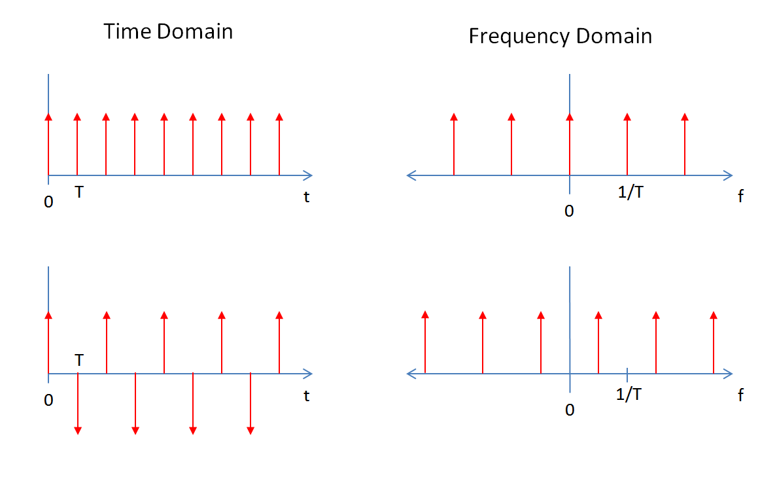

Figure 2:The spectrum of pulse (the train of delta in frequency domain).

## **Sampling**

The sampling theorem delineates two main techniques for converting a continuous-time signal into a discrete-time signal: natural sampling and flat-top sampling, also known as zero-order hold sampling. In natural sampling, samples are taken at the signal's natural frequency, whereas flat-top sampling involves regularly spaced samples with a specific duration. The distinction lies in the application of rectangular pulses in natural sampling, resulting in a perfect representation, while flat-top sampling yields samples with consistently flat tops, indicating a consistent amplitude.

Natural sampling, albeit providing a flawless representation, requires an infinite bandwidth. In contrast, flat-top sampling strikes a balance between practicality and accuracy. The tops of the samples in flat-top sampling have a uniform amplitude, contributing to its practicality.

The sample frequency, denoted as fs and equal to 2W, is referred to as the Nyquist rate. This rate represents the minimum frequency at which a signal must be sampled to enable distortion-free reconstruction from its samples. Failure to meet the Nyquist rate leads to aliasing, where the signal undergoes distortion during the sampling process.[2]

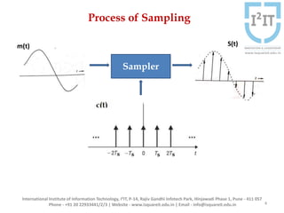

Figure 3:sampling

## **Aliasing**

When the sampling rate of an oscilloscope is insufficient to accurately capture the waveform, aliasing may occur. In simpler terms, aliasing happens when the sampling frequency is below the Nyquist rate. In such cases, it becomes impossible to recover the original message signal without distortion from the sampled data. To prevent aliasing, the sampling rate must be at least twice as high as the maximum frequency of the signal being measured.[3]

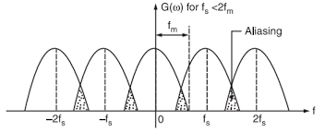

Figure 4:Aliasing

## **Time Division Multiplexing (TDM)**

Time Division Multiplexing (TDM) is a digital communication method facilitating multiple signals or data streams to share a unified communication channel. Each sender is allocated a specific time slot within the channel's overall bandwidth for a designated duration. Subsequently, the round-robin procedure ensures a seamless transition to the next sender. The TDM operation involves the partitioning of the time axis into N slots, each dedicated to a distinct source. The risk of collisions is mitigated as sources communicate solely within their assigned slots, optimizing the entire channel bandwidth. Following each transmission, the bandwidth becomes available for the subsequent user in the upcoming slot. This sequence of N slots constitutes a cycle. For effective transmission, TDM necessitates synchronization and a signal sampling rate surpassing the Nyquist rate.[4]

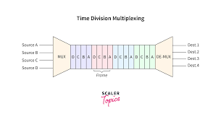

Figure 5:Time Division Multiplexing (TDM)

# **Procedure**

## **Time and Frequency Characteristics of pulse train**

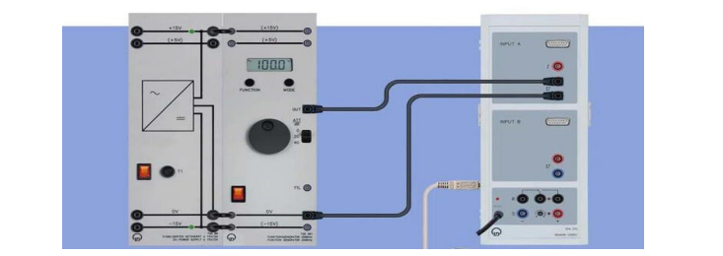

Figure 6:Connected of pulse train generator.

Initially, a pulse train was generated using a function generator with the following specifications: a frequency of 1 kHz, a voltage amplitude (VSS) of 10 volts, and a duty cycle of 10%.

To generate a pulse train with a 10% duty cycle, you would have a pulse that is "on" for 10% of the total period. Assuming a periodic signal, here's an expression for a pulse train with a 10% duty cycle over 5 cycles in the time domain:

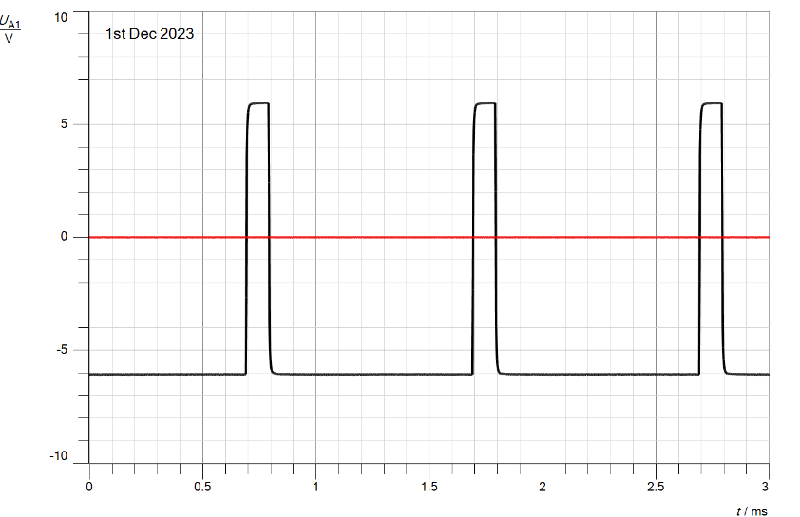

Figure 7:Pulse train with duty cycle = 10% in time domain.

In the frequency domain (the spectral representation of the aforementioned signal):

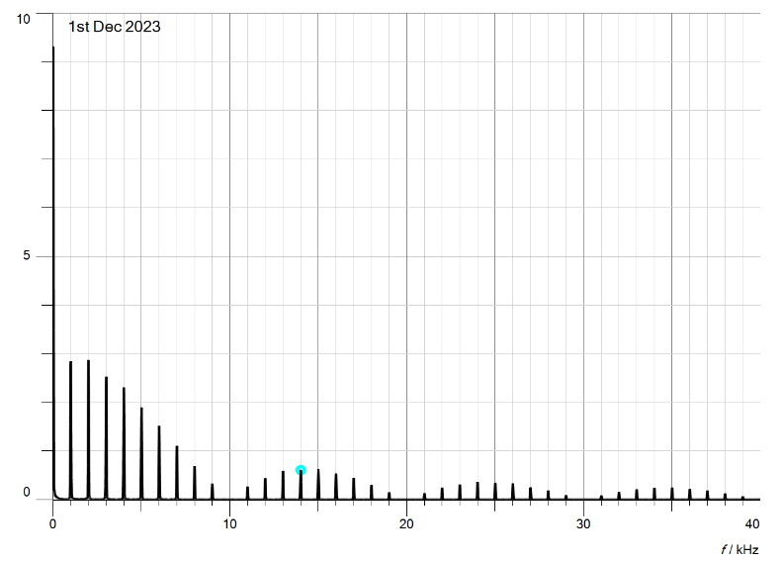

Figure 8:Spectrum of the pulse train with duty cycle =10%.

The zero crossings of the pulse spectrum can be determined by examining Figure 8. In the case of a pulse with a duty cycle of 10%, we observe that the first zero crossing occurs at 10 kHz, the second at 20 kHz, the third at 30 kHz, the fourth at 40 kHz, and the final one at 50 kHz.

Alternatively, the zero crossing can be theoretically calculated using the equation:

Zero crossing = n/t *f

Here, n represents the order of the zero crossing, t is the duty cycle, and f is the fundamental frequency of the pulse signal.

Since t is the duty cycle value, f is the frequency value, and n is an integer value (1, 2, 3,...), the zero crossing in this scenario is equal to 1/(10/100) * 1 KHz, or 10 KHz. This is the first zero crossing; 2/(10/100) * 1KHz = 20KHz represents the second zero crossing, and so on.

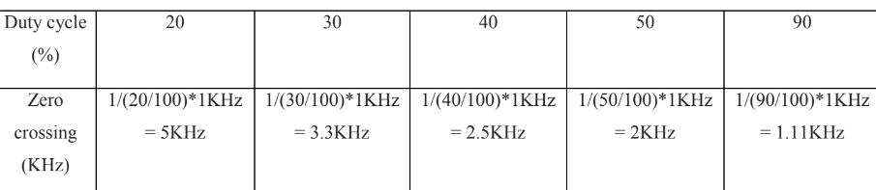

Figure 9:Zero crossings with different duty cycles.

The numbers in the above table were determined theoretically using the zero crossing equation, and their accuracy was confirmed by the figures in the spectrum pulse at each duty cycle value, as seen in the figures below.

Utilizing a 20% duty cycle and in time domain.

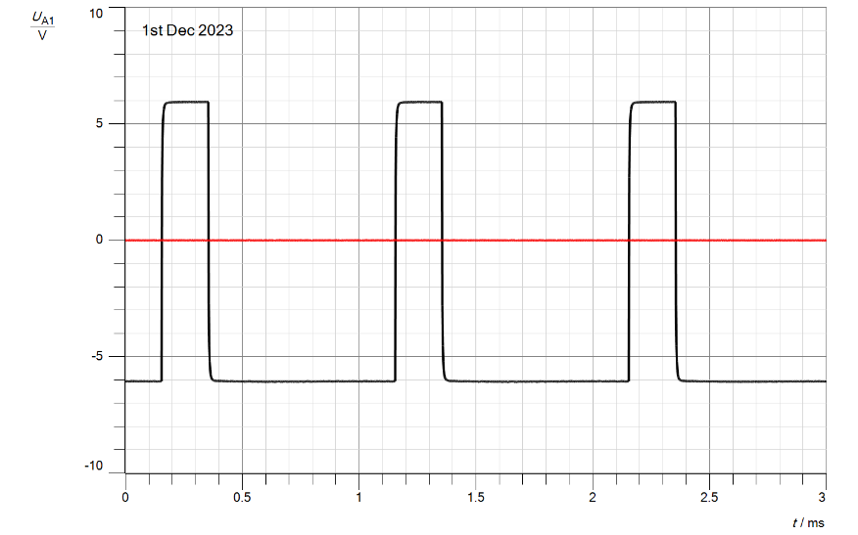

Figure 10:Pulse train with duty cycle = 20% in time domain.

And in freq

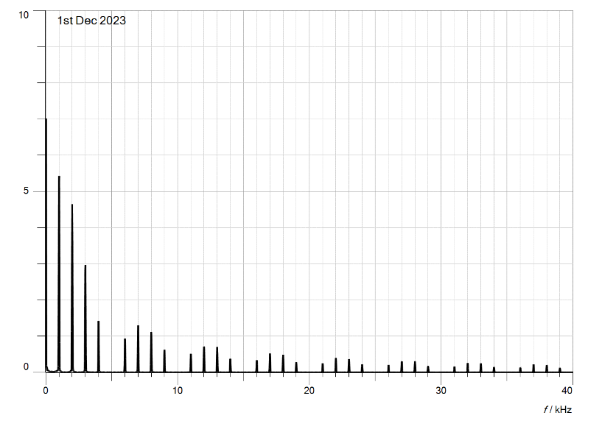

Figure 11:Spectrum of the pulse train with duty cycle =20%.

Ensure a 5KHz frequency for the initial zero crossing with a 20% duty cycle. The resulting pulses encompass a diverse range of frequencies, including higher harmonics. Transmitting these pulses without distortion or information loss demands an expanded bandwidth. This is due to the composition of pulse trains, which consist of numerous discrete pulses rapidly varying in both frequency and amplitude.

## **Characteristics of Pulse Amplitude Modulation (PAM)**

In this part, a square signal will be used to sample the message signal.

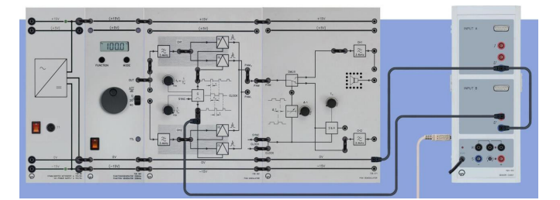

Figure 12:Connected of PAM.

The sampling frequency (fp) knob should be maximized first, then the duty cycle (τ∕TP) knob should be rotated to the three point side to reach its maximum value. Join Cassy UA1 to the output of the clock generator (G), Eventually, the spectral line of the fundamental pulse emerged at f0=5000Hz, indicating that the sampling frequency had been gradually reduced to 5000 Hz using the FFT analyzer measurement.

The spectrum appears at 5 KHz and at 10 KHz.

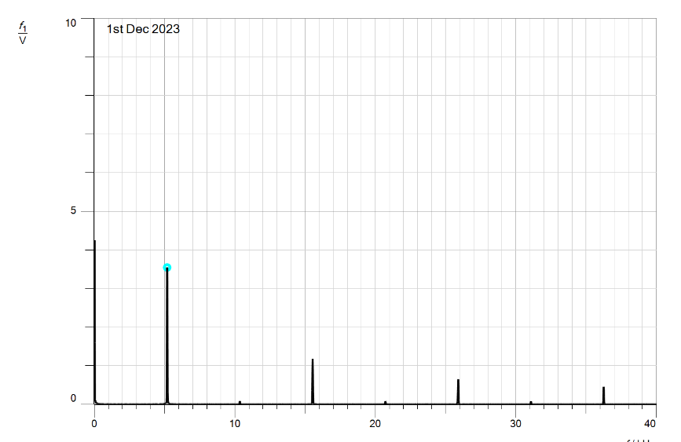

Figure 13:Spectral of pulse at 5 KHz and 15 KHz.

### **Study the effect of the channel filter (CH1):**

Set the function generator to generate a 500 Hz sine wave with a 10V peak-to-peak value. Then, link the Cassy sensor UB1 to the output signal of the CH1 filter with the indicated 5 cycle and the Cassy sensor UA1 to the input message signal.

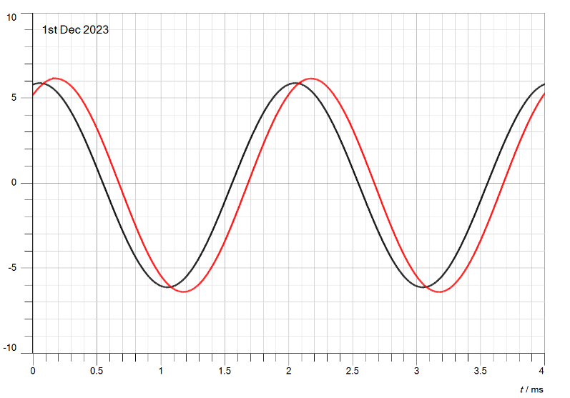

Figure 14:Original message signal with filtered message signal.

The spectrum of above figure:

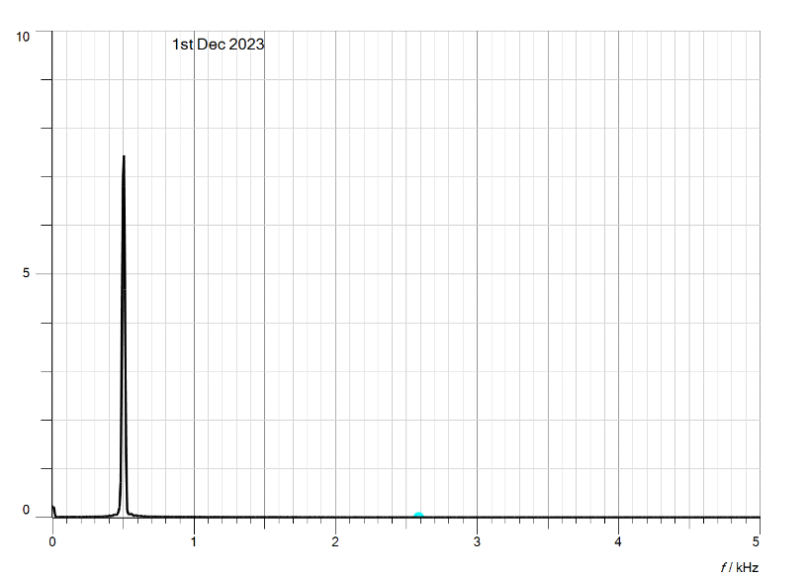

Figure 15:Spectrum of Original message signal and filtered message signal

The amplitude of the filtered signal (VO) divided by the amplitude of the input signal (Vi) equals the gain of the filter at 500 Hz in figure (15): 7.6/7.3 = 1.041.

### **Display the Pulse Amplitude Modulated signal s(t) of PAM1 in the time domain:**

Set the function generator to generate a sine wave with a peak-to-peak (Vss) value of 10V and a frequency of 500 Hz. The Cassy sensor UB1 should then be connected to the PAM1 output and the Cassy sensor UA1 to the CH1 filter's output signal, as shown by the fifth cycle.

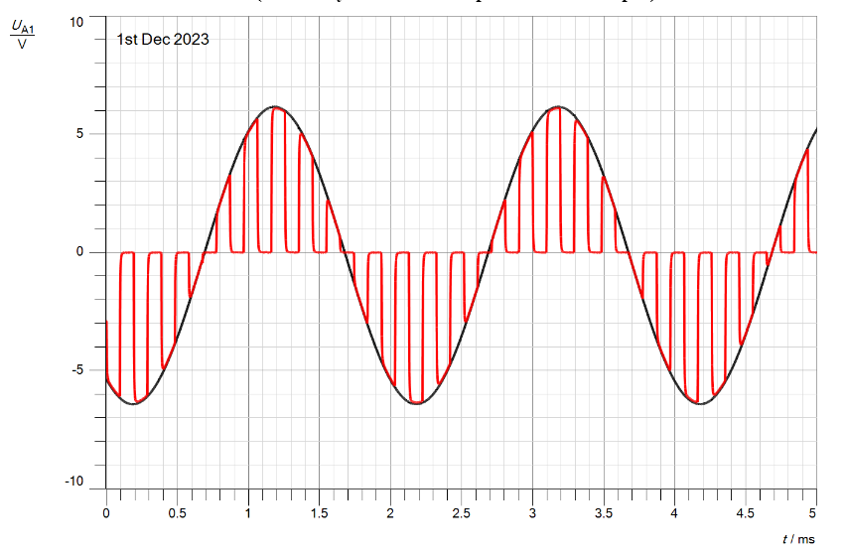

Figure 16:modulated signal S(t) of PAM1 and input signal in time domain with duty cycle 50%.

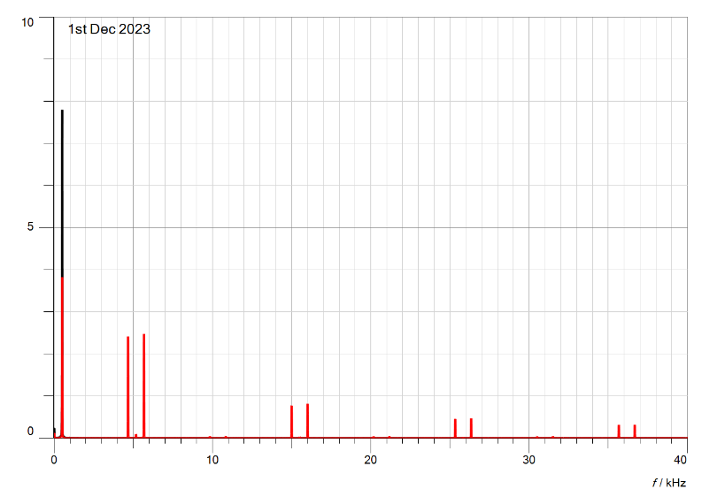

Figure 17:Spectrum of modulated signal S(t) of PAM1 and input signal.

From figure (16) above, we can conclude that the PAM1 use natural filter because it take the shape of input signal (sinusoidal shape).

### **Determining the effect of the duty cycle on the PAM in the time domain:**

when the clock generator's duty cycle is lowered to the minimum value.

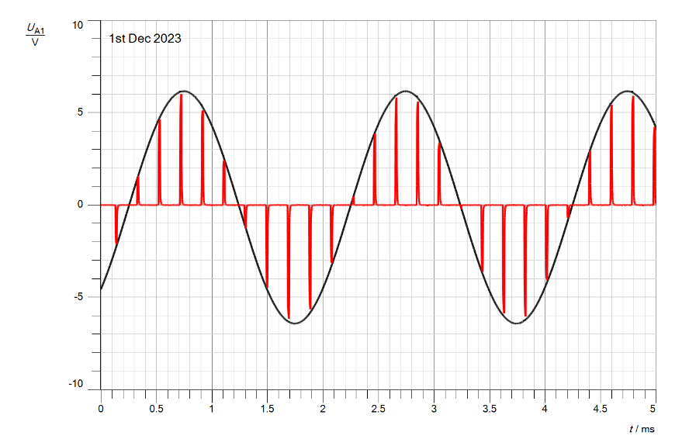

Figure 18:Modulated signal S(t) of PAM1and input signal with minimum value duty cycle =10% in time domain.

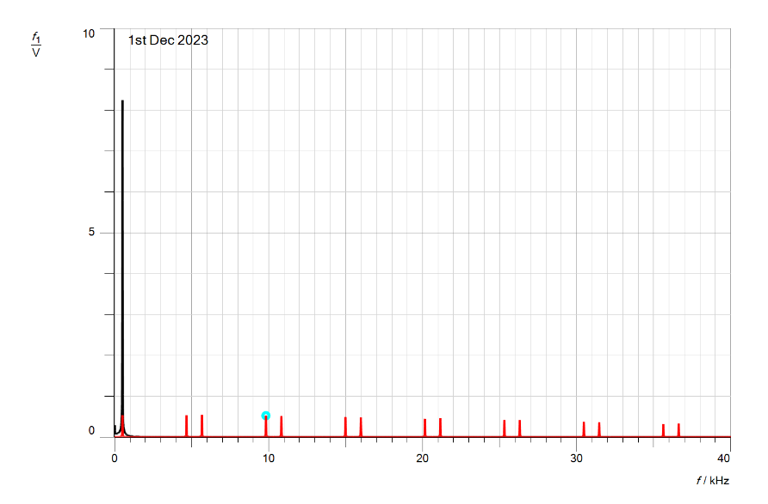

Figure 19:Spectrum of modulated signal S(t) of PAM1and input signal with minimum value duty cycle =10%

Because the duty cycle (pulse in "on / high mode" period) has dropped, reducing the duty cycle also led to reducing the sampling train's pulse width.Top of Form

### **Display the Pulse Amplitude Modulated signal s(t) of PAM1 in the Frequency domain:**

Maintain the existing connection while adjusting the duty cycle of the clock generator to its maximum value (turn the knob towards the side with three black points). Subsequently, link the Cassy sensor UA1 to the output of the clock generator.

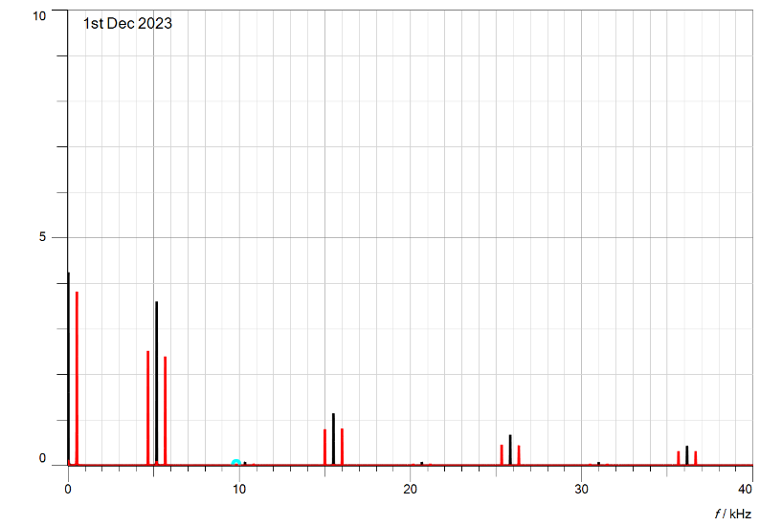

Figure 20:Frequency-domain modulated signal PAM1 s(t) with the clock spectrum.

The red signal represents the clock, and the black signal PAM1. As can be seen in the above image, the clock's amplitude is greater than the PAM1 signal's due to its higher frequency.

### **Determining the effect of the message frequency on the PAM in the Frequency domain:**

When change the message frequency to 1kHz

In figure bellow the black signal is PAM1.

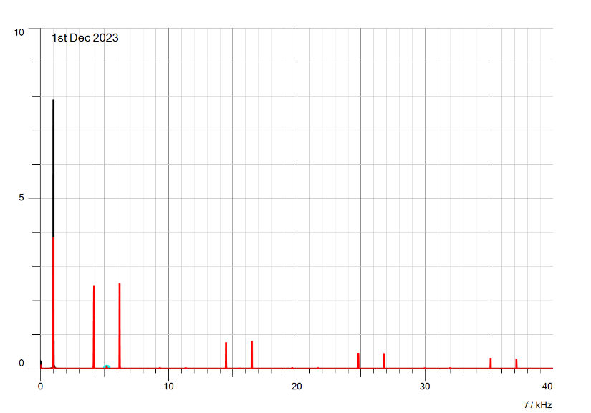

Figure 21:PAM1 signal at 1KH in frequency domain.

When change the message frequency to 2kHz

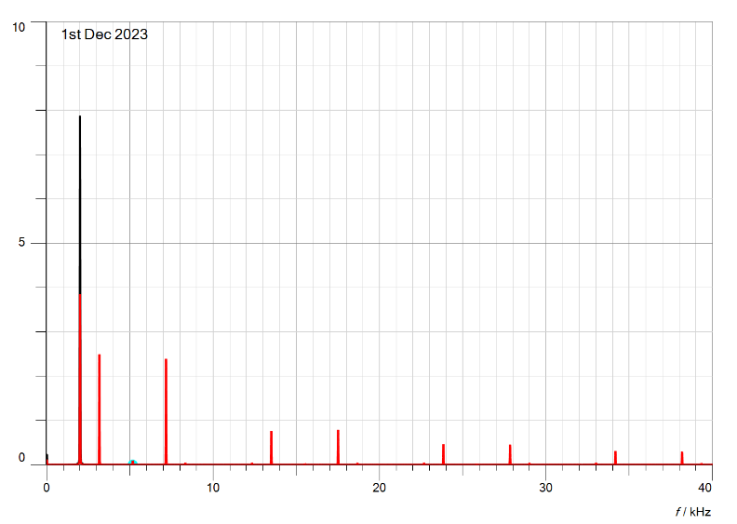

Figure 22:PAM1 signal at 2KH in frequency domain.

the message signal influence on PAM spectrum, the value of the message signal frequency it’s exhibited between each spectrum lines.

### **Determining the effect of the duty cycle on the PAM in the Frequency domain:**

When the clock generator's duty cycle is reduced to 10% (the minimum), and the message frequency is set to 500 Hz.

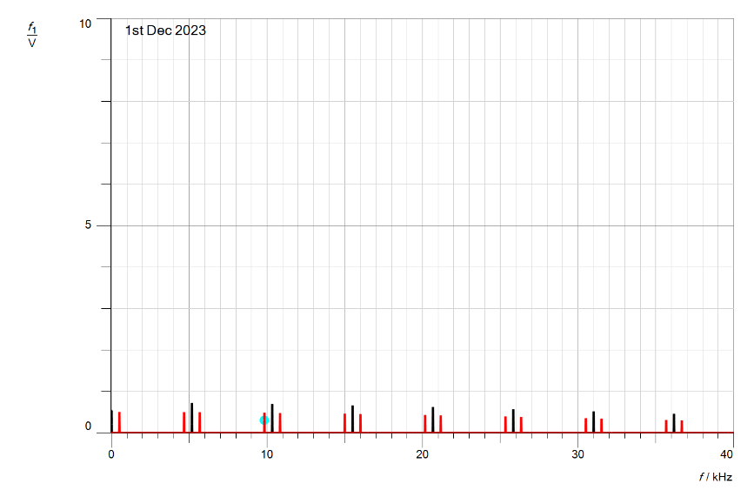

Figure 23:Spectrum of PAM1 with fm=500Hz and duty cycle = 10%.

When the message frequency is set to 500 Hz and the clock generator's duty cycle is adjusted to 30% (with the knob in the center),

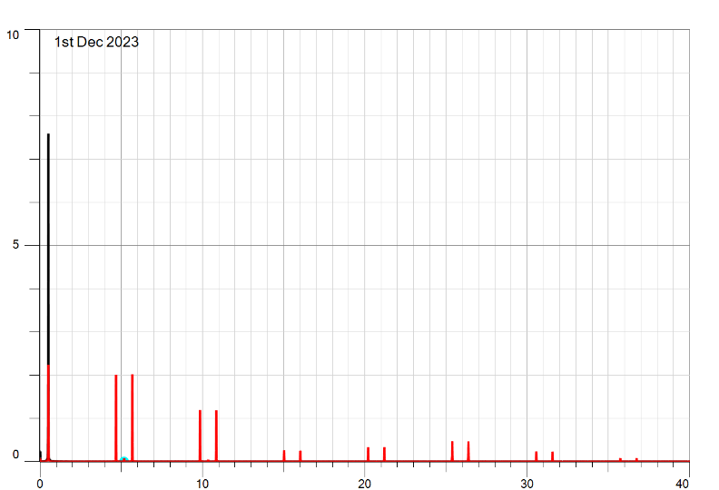

Figure 24:Spectrum of PAM1 with fm=500Hz and duty cycle = 30%.

### **Display the Pulse Amplitude Modulated signal s(t) of PAM2 in the time domain:**

Connect the Cassy sensor UA1 to the CH1 filter's output signal and UB1 to the PAM2 output after setting the function generator to a sine wave with a frequency of 500 Hz and a peek-to-peak voltage of 10 volts. Return the clock generator's duty cycle to 50%.

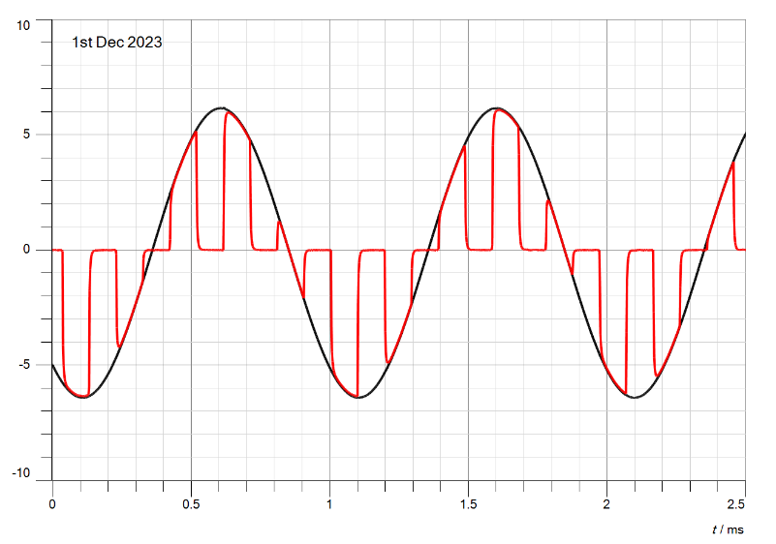

Figure 25:PAM2 modulated signal s(t) time domain.

As shown in the figure above that using the flat top sampling filter, as the peek value for sampled is constant.

### **Determining the effect of the duty cycle on the PAM in the time domain:**

When lower the duty cycle to the min.

Figure 26 below illustrates how the duty cycle affects the PAM signal. When the duty cycle is set to minimum, the pulse's width narrows and becomes sharper, but the interval between pulses increases.

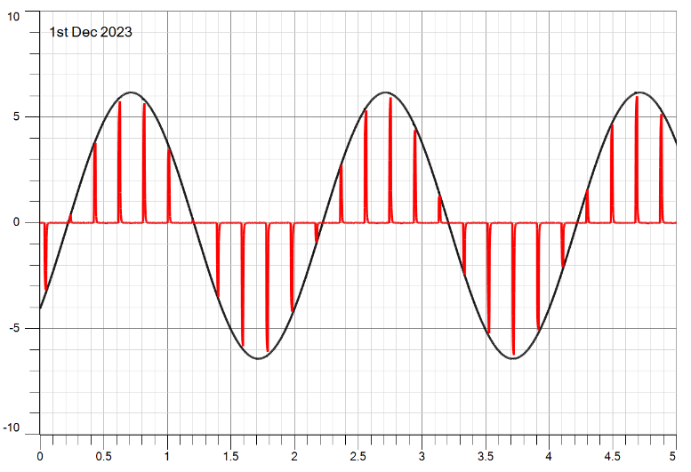

Figure 26:PAM2 with minimum duty cycle.

### **Display the Pulse Amplitude Modulated signal s(t) of PAM2 in the Frequency domain:**

Connect the Cassy sensor UA1 to the clock generator's output using the same connection as before, making sure the clock generator's duty cycle is set to the maximum value.

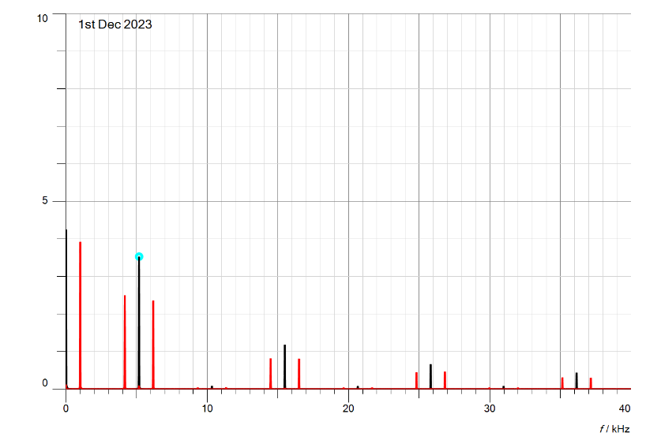

Figure 27:Spectrum of PAM2 maximum duty cycle.

### **Determining the effect of the message frequency on the PAM in the Frequency domain:**

With change the message frequency to 1kHz.

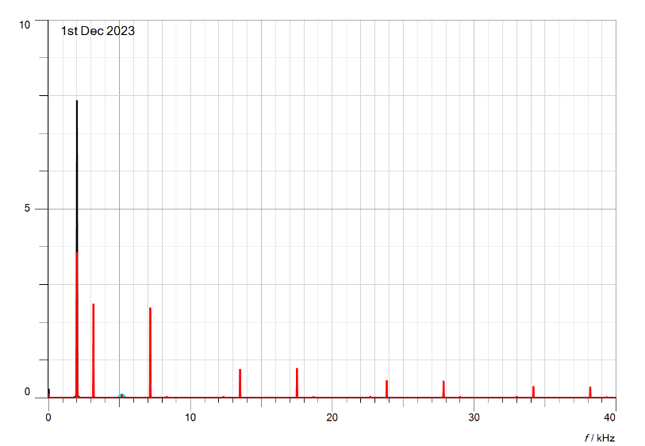

Figure 28:PAM2 spectrum at 1KHz.

In 2KH

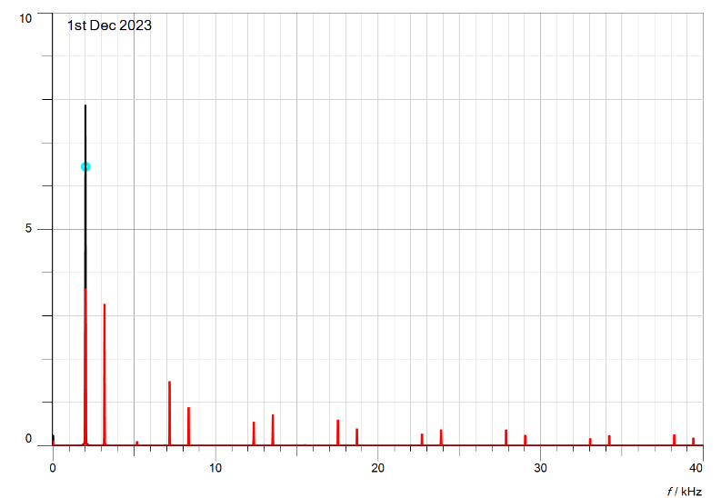

Figure 29:PAM2 spectrum at 2KHz.

### **Determining the effect of the duty cycle on the PAM in the Frequency domain:**

Set the message frequency back to 500Hz and change the duty cycle of the clock generator to 10%.

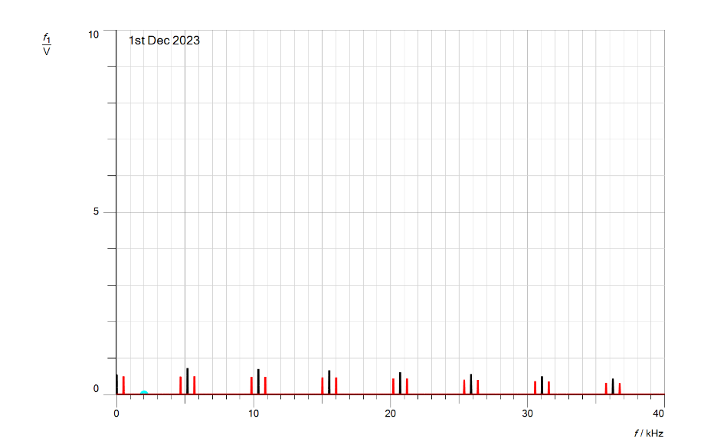

Figure 30:Spectrum of PAM2 with duty cycle 10%.

Return the message frequency to 500 Hz and adjust the clock generator's duty cycle to 10%.

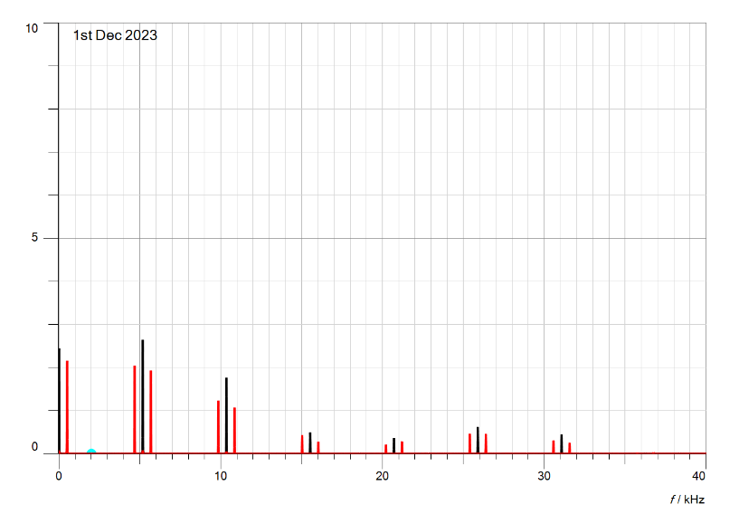

Figure 31:Spectrum of PAM2 with duty cycle 30%.

## **Characteristics of Pulse Amplitude Demodulation**

### **Display the message signal and the demodulated signal using PAM1:**

When the function generator is set to sine wave, with frequency = 500 Hz, Vss = 10V, and the clock generator frequency at its maximum value, Attach the Cassy sensor UA1 to the CH1 filter's input signal and UB1 to the CH1 demodulator filter's output.

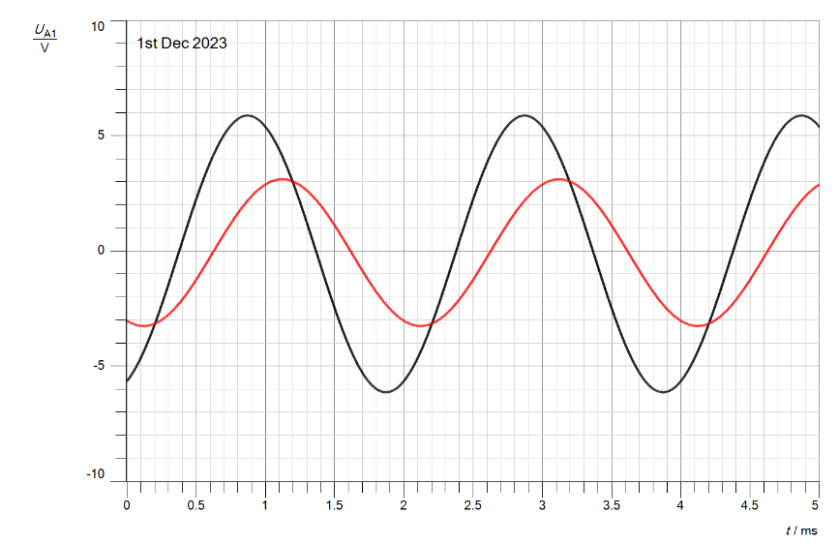

Figure 32:demodulated signal with filtered input signal in time domain.

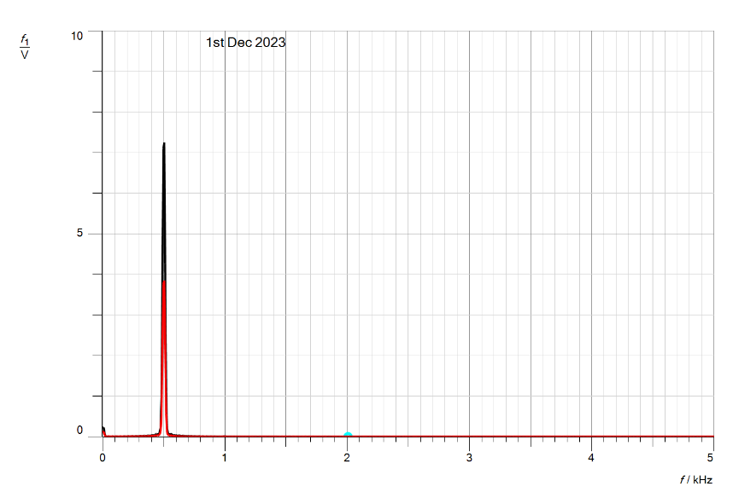

Figure 33:demodulated signal with filtered input signal in frequency domain.

### **Determining the effect of the duty cycle on the PAM in the time domain:**

#### **When change the duty cycle of the clock generator to 10%**

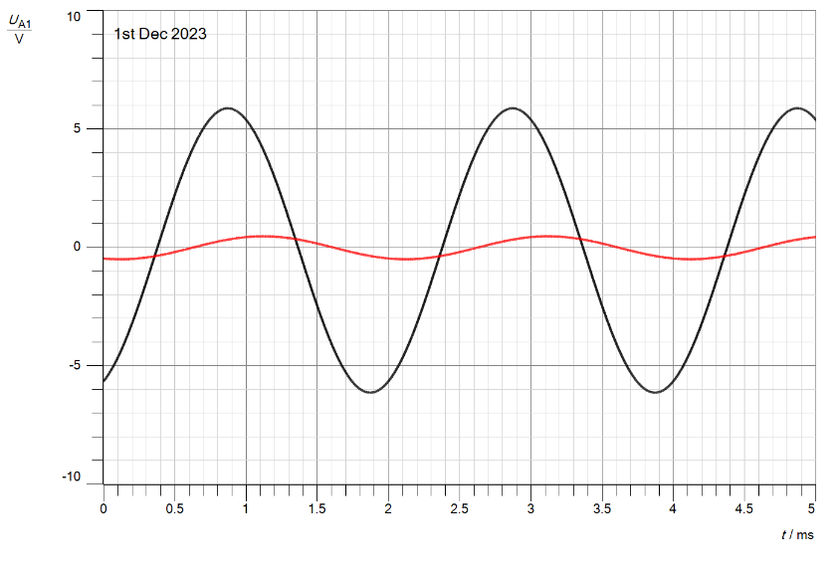

Figure 34:Demodulation of message signal and input signal with duty cycle =10% in time domain.

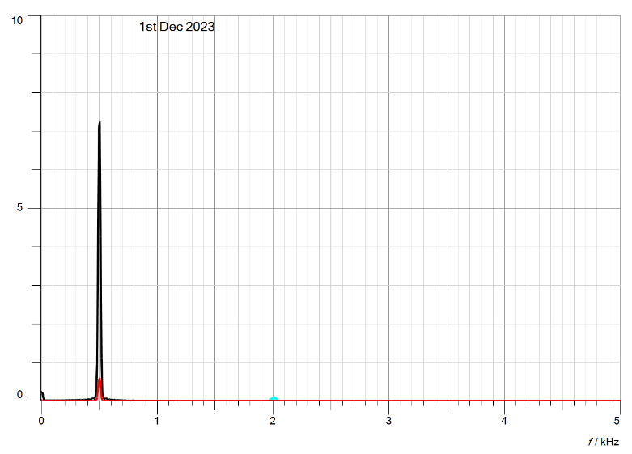

Figure 35:Demodulation of message signal and input signal with duty cycle =10% in frequency domain.

#### **When change the duty cycle of the clock generator to 30%**

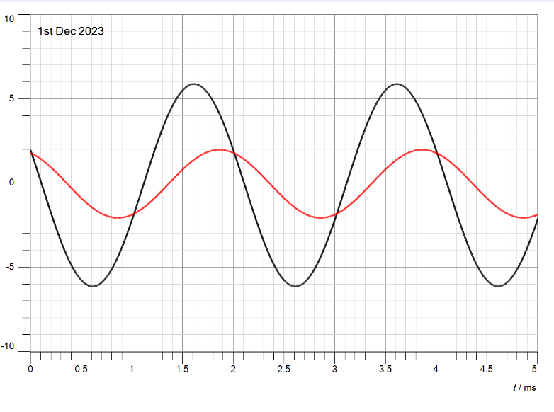

Figure 36:Demodulation of message signal and input signal with duty cycle =30% in time domain.

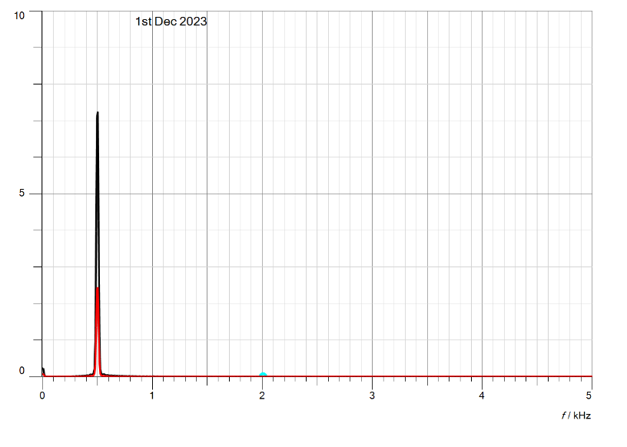

Figure 37:Demodulation of message signal and input signal with duty cycle =30% in frequency domain.

We may thus assume that when the duty cycle is decreased, the signal's amplitude and breadth, or period of time, will likewise drop. This will cause the data transmission to slow down, which might result in signal distortion.

## **Aliasing in the Time and the Frequency Domains**

### **Display the message signal and the demodulated signal using PAM1 in the time domain:**

Set the function generator to a sine wave with frequency = 3000 Hz and voltage = 5V. Connect the Cassy sensor UA1 to the CH1 filter's output signal and UB1 to the PAM1 modulator. Set the clock generator's frequency to 5000 Hz and duty cycle to 50%.

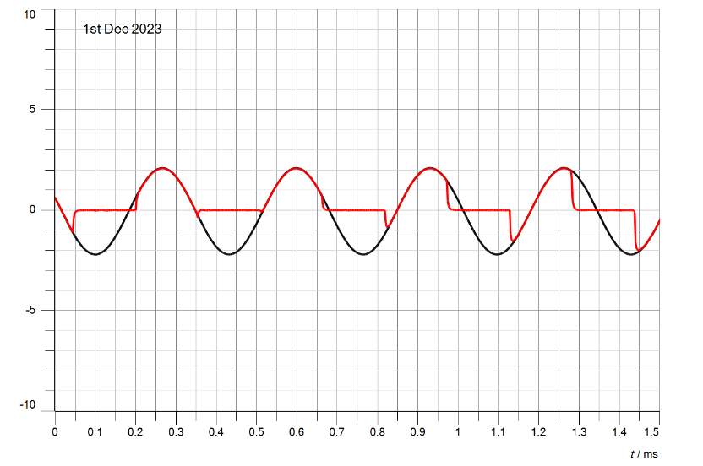

Figure 38:Aliasing output signal in time domain.

When connect the Cassy sensor UB1 to the output of the demodulator filter of CH1.

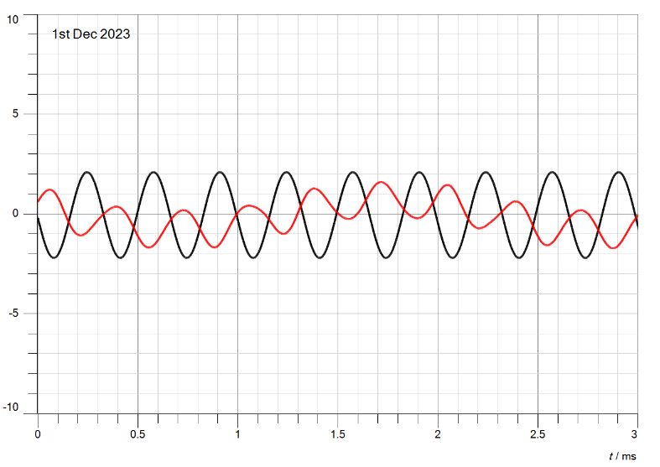

Figure 39:Output of demodulator filter in time domain.

Since the sampling frequency in this instance was 5000 Hz, which is less than 2 *fm (= 2 * 3000 = 6000), aliasing occurred because the frequency of sampling did not achieve the Nyquist rate (frequency of sampling (fs) >= 2 *message frequency (fm)). As a result, the original message signal could not be recovered from the aliasing demodulator.

### **Display the message and the demodulated signals using PAM1 in the frequency domain:**

When utilize the same message setup in previous section in time domain with link the Cassy sensor UA1 to the output of the clock generator and UB1 to the PAM1 modulator.

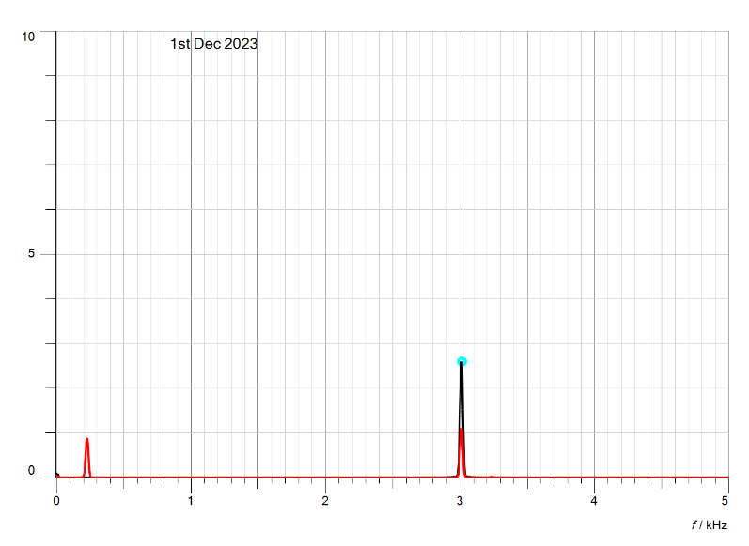

Figure 40:spectrum of clock generator with PAM1.

When connect the Cassy sensor UB1 to the output of the demodulator filter of CH1.



Figure 41:Output of demodulator filter with PAM1.

## **PAM Time Multiplex**

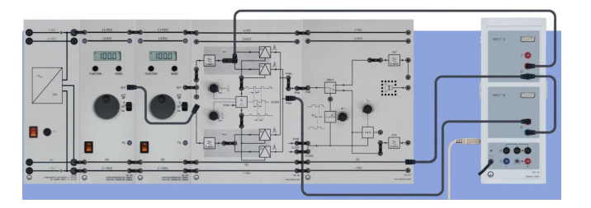

Figure 42:Connected of PAM time multiplex.

### **Display the time characteristic of the time multiplex signal.**

The CASSY sensor UA1 is connected to the triangle message channel CH1, UB1 to the output PAM modulator PAM1.r after the sampling frequency (fP) and duty cycle (dC) have been set to their maximum values. The first function generator of the triangle signal (fM1 = 200 Hz, VSS = 5 V) and the second function generator (fM2 = 300 Hz, VSS = 10 V) have also been set.

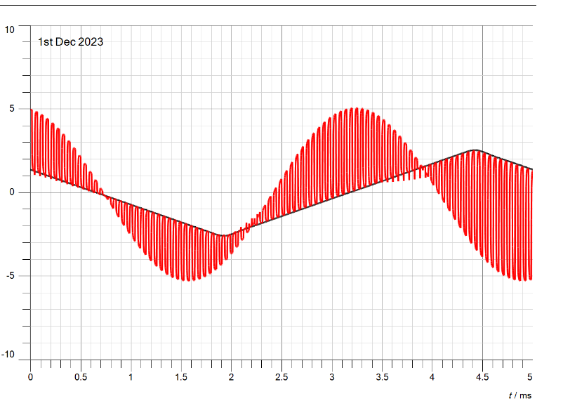

Figure 43:Output PAM modulator PAM1 with triangle message signal.

### **Connect the CASSY sensor UA1 to the sine message channel CH1.**

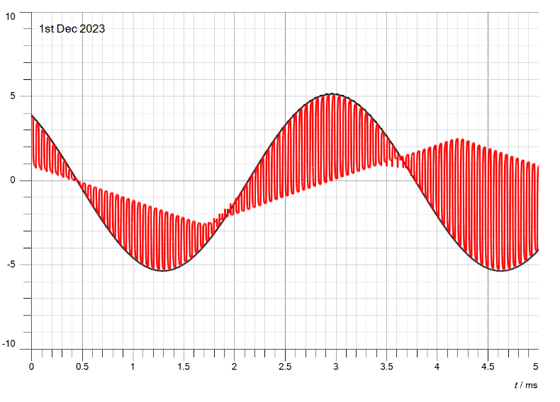

Figure 44:Output PAM modulator PAM1 with sine message signal.

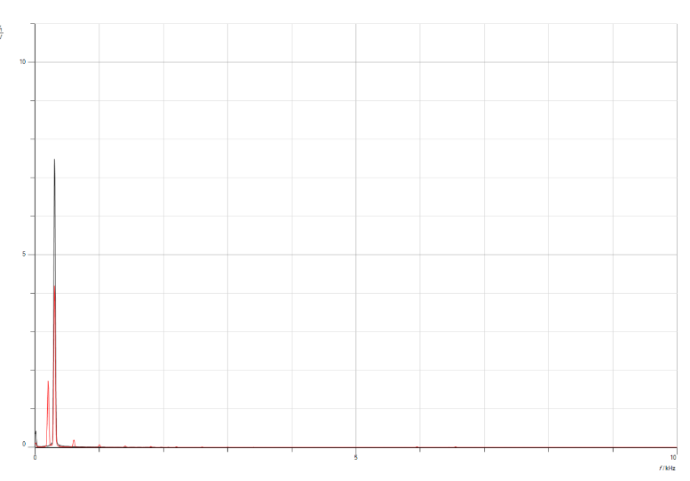

Figure 45:Output PAM modulator PAM1 with sine message signal in frequency domain.

### **When Connect the CASSY sensor UA1 to the demodulator filter CH1, sensor UB1 to the**

### **demodulator filter CH2.**

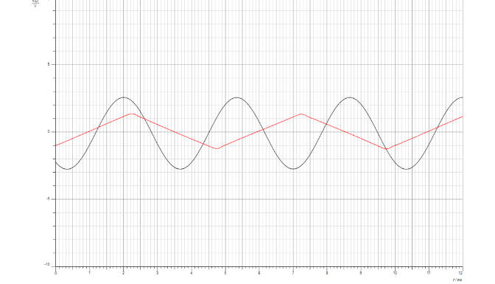

Figure 46:demodulator filter in ch1 and ch2 in time domain.

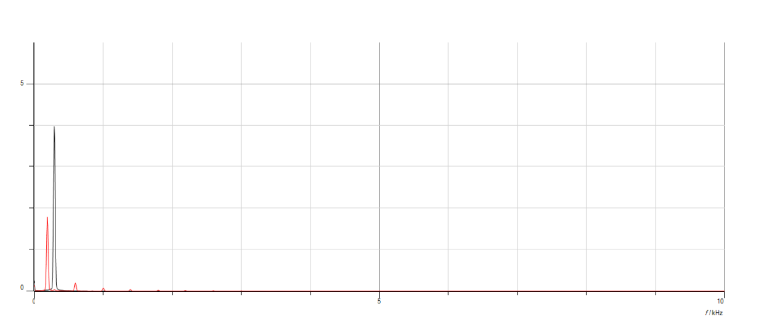

Figure 47:demodulator filter in ch1 and ch2 in frequency domain.

### **Cross Talk (Δt) left/middle**

When the system is unable to keep synchronization, cross talk occurs. Here, a fragment of the first message, m1(t), is created at the spot where the second message signal, m2(t) go, and vice versa.

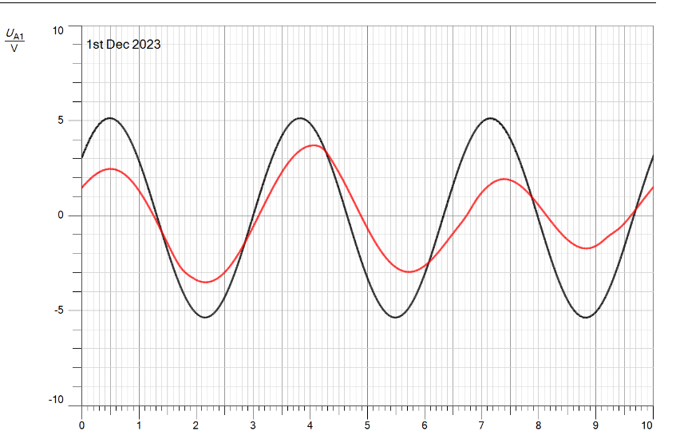

Figure 48:Cross Talk in time domain.

As we seen in above figure, that the 2 signal don’t synchronization to each other.

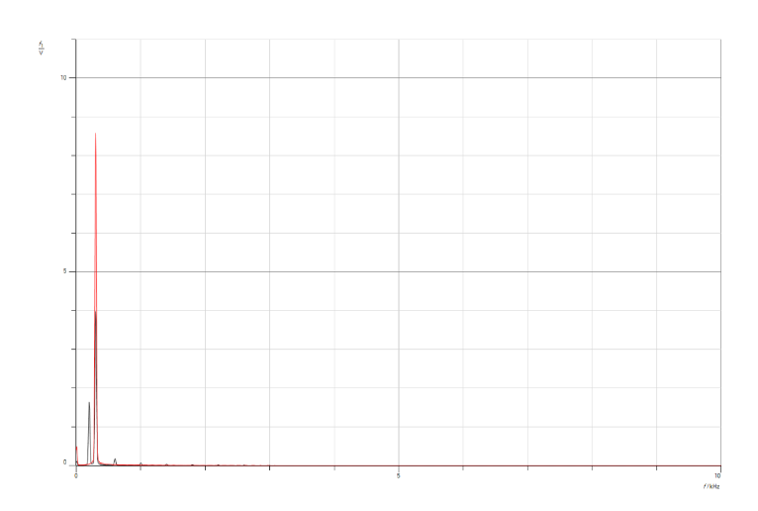

Figure 49:Cross Talk in frequency domain.

Set the first function generator to Triangle, fM1 = 200 Hz, VSS = 10 V

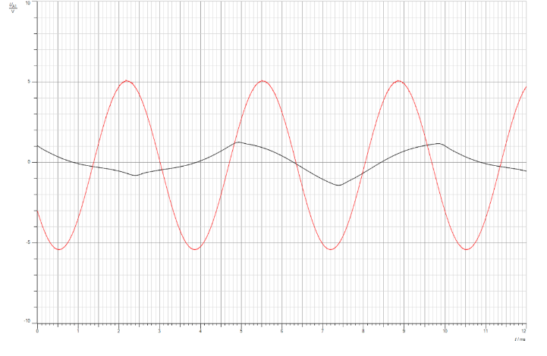

Figure 50:Cross Talk with triangle in time domain.

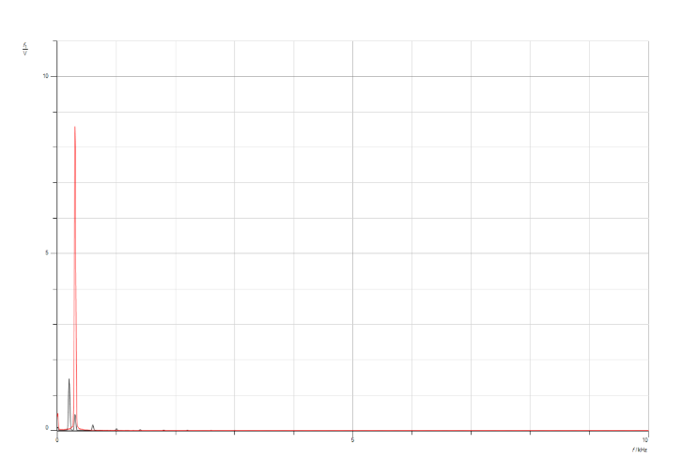

Figure 51:Cross Talk with triangle in frequency domain.

Set the second function generator to Sine, fM2 = 300 Hz, VSS = 10 V.

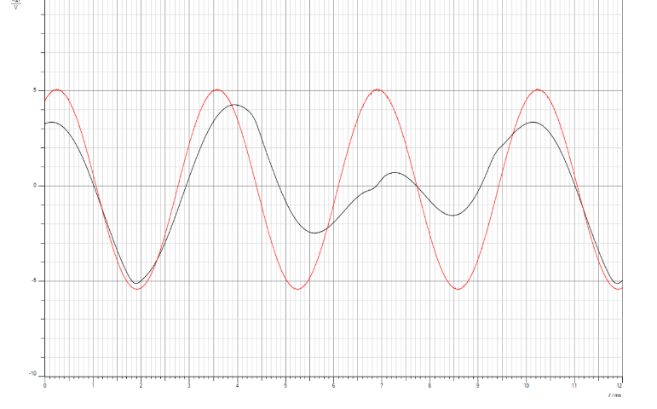

Figure 52:Cross Talk with sine in time domain.

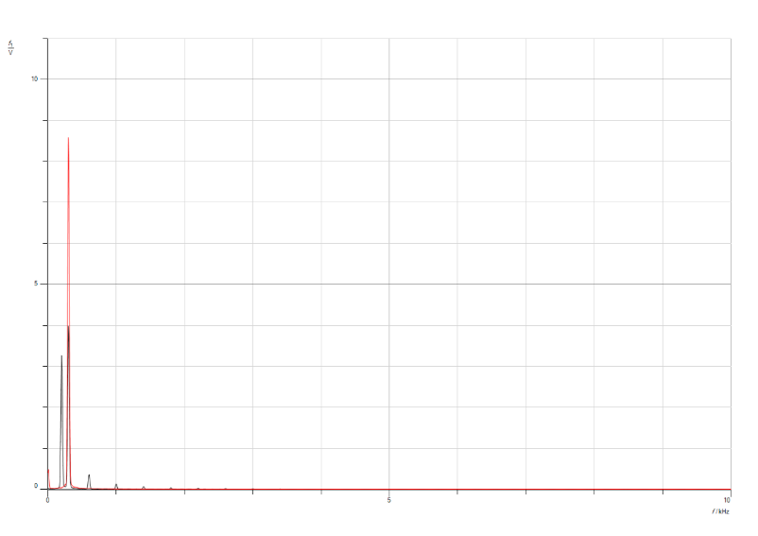

Figure 53:Cross Talk with sine in frequency domain.

# **Conclusion**

In conclusion, this experiment provided practical insights into the theoretical concepts of pulse amplitude modulation (sampling). Through hands-on application, we successfully constructed various circuits for different components of the experiment, including modulation and demodulation techniques. Our exploration extended to analyzing the impact of altering the duty cycle value on signals within both time and frequency domains.

The experiment further acquainted us with different types of filters, such as natural filter and flat top filter sampling. We systematically observed the resulting signal shapes from each filter, understanding their effects on the signals. Additionally, we gained knowledge about the Nyquist rate principle, recognizing its significance and the consequences of failing to adhere to it, leading to aliasing.

Furthermore, the experiment enlightened us on pulse amplitude modulation time multiplex, elucidating its configuration with different types of input signals. Overall, this comprehensive exploration not only clarified theoretical information but also equipped us with practical skills and a deeper understanding of various aspects of pulse amplitude modulation.

# **References**

[1] <https://www.sciencedirect.com/topics/engineering/periodic-pulse-train#:~:text=1%20Sampling,is%20called%20the%20Nyquist%20rate>. Accessed at 15/1/2024 at 10:16 pm.

[2] <https://www.geeksforgeeks.org/sampling-in-digital-communication/> Accessed at 15/1/2024 at 10:50 pm.

[3] <https://www.tek.com/en/support/faqs/what-aliasing-and-how-do-i-detect-it-and-fix-it-my-oscilloscope> Accessed at 15/1/2024 at 11:10 pm.

[4] <https://www.quora.com/What-is-time-division-multiplexing> Accessed at 15/1/2024 at 11:25 pm.